|  |
| --- |
| **Identity card of the specialty:**Master's degreeElectronics of Embedded Systems |

Level: Academic Master

**Domain:**Science and Technology

**Sector:**Electronic

**Speciality:**Electronics of Embedded Systems

|  |
| --- |
| **1- Location of the training:** |

**Faculty (or Institute): Technology.**

**Department: Electronics.**

**References of the enabling order: Order no.**1201 on 08/09/2016

|  |
| --- |
| **2- External partners:** |

**Companies and other socio-economic partners**:/

**International partners**:/

**Other partner establishments**: Algeria Telecom Bechar, Sonelgaz Bechar, TDA Bechar, GICA Bechar

|  |
| --- |
| **3- General organization of the training: position of the project** |

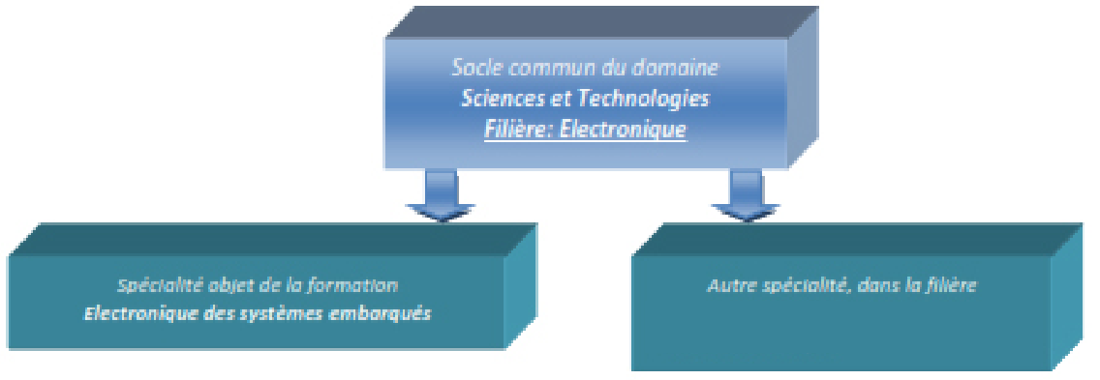

|  |
| --- |
| **4- Context of the training:** |

Today, electronics is one of the essential fields of the world economy, at the origin of or contributing to many innovative fields, such as in particular those of computing, embedded systems and telecommunications. It is therefore increasingly present in most everyday objects in very diverse forms. This discipline covers the analysis and design of components, circuits and systems as well as hardware/software co-integration for the realization of control, command, calculation and interface in the case of complex systems.

The main objective of the proposed master is to train specialists in the field, which opens the way to a wide range of integrations in technological establishments, research centers and university establishments. There is a growing demand for electronics professionals in many aspects of research and engineering, ranging from the design of tools and sensors to complex systems in the petroleum, aerospace, chemical industries. , biomedical, automotive and others.

|  |
| --- |
| **5- Objectives of the training:** |

The objective of electronic training is to provide solid scientific and technical training in the fields of electronics.

This training, which falls within the field of Science and Technology, is based on the one hand on fundamental subjects (maths, physics, chemistry and computer science up to 40%: 72/180 credits) and on the other hand on subjects closely related electronics, namely: analog and digital electronics, servo-control, power electronics, signal processing, etc. (87/180 credits, i.e. nearly 50%). On another note, the pedagogy in this training is resolutely oriented towards experience. To this end, a large part was intended for practical work sessions (25% of the total hourly volume): almost all of the specialty subjects are reinforced by practical work sessions. At the same time, students are trained in collective work in order to promote autonomy,

|  |
| --- |
| **6- Profiles and skills targeted:** |

this Master in Electronics of Embedded Systems is for academic purposes. It primarily aims to:

– Train students capable of pursuing studies in all types of existing Masters in electronics, or even later in doctorate;

– Acquire a diploma recognized by the socio-economic environment (local, regional and national) and adapt to the current and future needs of our society.

Indeed, this training is a springboard for a very wide range of electronics professions (space exploration, automotive, radio, television, telephony, medicine, robotics, imaging, industrial computing, embedded systems, etc.). Training in this field therefore offers many professional opportunities in a wide variety of industries.

|  |
| --- |
| **7- Local, regional and national employability potential:** |

At the end of this training, the graduate can not only pursue higher education (Master's, Doctorate) but he is also able to occupy a job as a general-purpose manager in electronics, called upon to meet local, regional and national needs.

– Electricity production and distribution company;

– Telecommunications and automotive sector;

– Small or medium-sized companies in the electronics sector;

– Industrial companies;

– Chemical engineering companies;

– Teaching and research.