|  |
| --- |
| **Identity card of the specialty**Architecture |

**Level:**Master

**Domain:**Architecture, Urban Planning and City Professions AUMV

**Sector:**Architecture

**Speciality:**Architecture

|  |
| --- |
| **1- Location of the training:** |

**Faculty (or Institute)**: faculty of technology, UTMB

**Department**:Architecture

References of the order authorizing the diploma to be prepared Order No. 752 of 08/26/2018

|  |
| --- |
| **2- External partners:** |

**Companies and other socio-economic partners**: Department of Architecture, Urban Planning and Construction DAUC of Béchar, Department of Housing DL Béchar, Department of Public Facilities of Béchar, Department of Transport of Béchar, Department of Hydraulics of Béchar, Department of Béchar, Land Registry Department of Béchar, Department of Public Works of Béchar, Land Agency of the commune of Béchar, Local authorities of the wilaya, The URBAT study office (Center for Studies and Achievements in Urbanism of Béchar), The Office of studies of the wilaya of Béchar, private BET, AADL Béchar.

**International partners**: name of international partners

**Other partner establishments**: Polytechnic School of Architecture and Urban Planning (EPAU), University Salah Boubnider Constantine 3, University of Science and Technology of Oran USTO.

|  |
| --- |
| **3- General organization of the training: position of the project** |

|  |
| --- |
| **4- Context of the training:** |

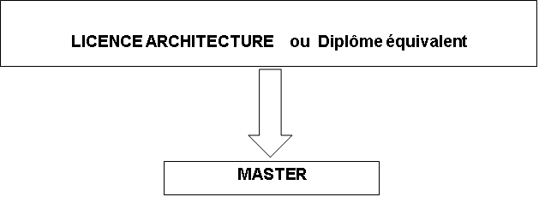

|  |
| --- |
| **5- Objectives of the training:** |

The objectives of the training aim to prepare a “professional” endowed with the skills, capacities and abilities favoring his participation in the qualitative production, the promotion of architecture and the protection of the built heritage.

Thus all architectural production is called upon to preserve the quality of public interest that natural and urban landscapes assume. Any intervention therefore requires the intervention of a professional with adequate skills to exercise the profession of architect.

At the end of the training, the learner will be able to design, develop and lead an architectural project. These capacities will be accompanied by transversal and specific skills.

The first consist of a mastery of communicative skills at university level (oral and written), of an appropriate personal culture and of knowledge to be mobilized beyond the exercise of one's profession.

The second relate to the discipline or specialty. These are therefore skills that promote the mobilization of knowledge for the exercise of the profession.

In short, the training aims to set up a framework endowed with the knowledge, the know-how and the know-how ready to be mobilized to accomplish the missions falling within its competence in the rules of the art.

|  |
| --- |
| **6- Profiles and skills targeted:** |

the main activities of the professional are focused on the mastery of the proposals of the creation projects until the execution project with aptitudes to ensure the follow-up of the works -GO, CES).. These professional charges call on basic skills: knowledge of law, standards and market codes, know-how in setting up and running projects as well as mastering technical tools.

Regarding legislative texts, Legislative Decree No. 94-07 of May 18, 1994 amended by Law No. 04-06 of August 14, 2004 relating to the conditions of architectural production and the exercise of the profession of architect, remains the only reference in terms of framing, field and prerogatives in the activity of the architect. Architecture is defined in terms of knowledge and know-how in the art of building (Art.2). These skills are required of a project manager, in the person of the approved architect (art. 9).

The training is therefore developed to set up a framework called upon to ensure activities in the field of architectural production, but also to be able to devote themselves to research in the field bringing together related disciplines.

Restoration and conservation of heritage, eco-construction and sustainable development, construction and building site, expertise, consulting and technical advice; administration and public service, real estate expertise; industry and business education and research finance and property management.

|  |
| --- |
| **7- Local, regional and national employability potential:** |

The distribution of training points in Architecture on the national territory can help cover production needs in the construction sector.

The variety of tasks and missions devolved to the profession of architect is part of the demand of all sectors, organizations and institutions related to urban services, local authorities and construction.

The production of the building also requires management and maintenance services, ensuring tasks of updating, requalification and rehabilitation of the living environment.

Private work is also considered. Approval follows a procedure including completion of a professional internship and registration on the National Roll of the Order of Architects.

In conclusion, employability is ensured to the extent of the needs of the sectors and services of urban and municipal bodies.