|  |
| --- |
| **Identity card of the specialty:**MASTERS IN TELECOMMUNICATIONS SYSTEMS |

**Level:**Academic Masters

**Domain:**Science and Technology

**Sector:**Telecommunications

**Speciality:**Telecommunications Systems

|  |
| --- |
| **1- Location of the training:** |

**Faculty (or Institute)**:TECHNOLOGY

**Department**:Electrical Engineering.

References of the authorization order: Order no. 1201 of 08/09/2016.

|  |
| --- |
| **2- External partners:** |

**Companies and other socio-economic partners**:/

**International partners**:/

**Other partner establishments**: Sonelgaz of the production SPE Bechar/Ghardaïa, Sonelgaz distribution Bechar, Sonelgaz of the Transport of electrical energy THT/HT GRTE Bechar /Oran, Algérie Telecom, NAFTAL (GPL, CPL) Bechar, GICA Saoura Bechar

|  |
| --- |
| **3- General organization of the training: position of the project** |

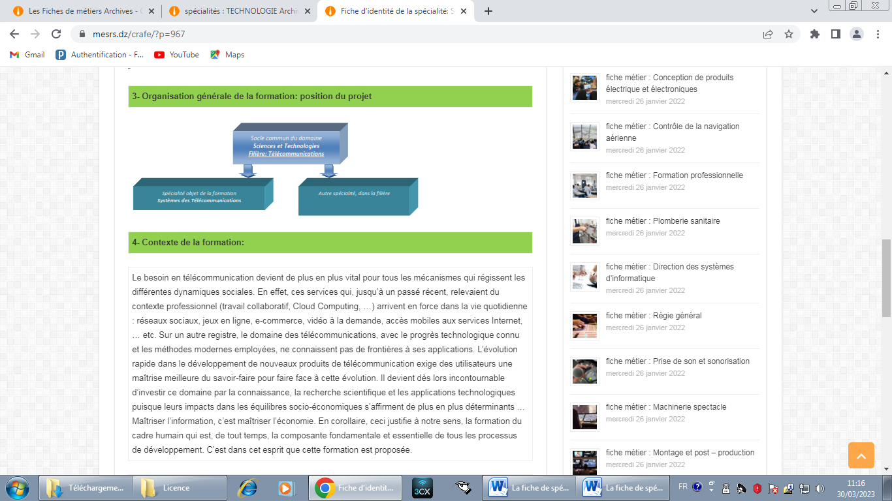

|  |
| --- |
| **4- Context of the training:** |

The need for telecommunications is becoming more and more vital for all the mechanisms that govern the different social dynamics. Indeed, these services which, until the recent past, fell within the professional context (collaborative work, Cloud Computing, etc.) are arriving in force in daily life: social networks, online games, e-commerce, video on demand , mobile access to Internet services, etc. On another register, the field of telecommunications, with the known technological progress and the modern methods employed, know no borders to its applications. The rapid evolution in the development of new telecommunication products requires users to better master the know-how to cope with this evolution. It therefore becomes essential to invest this area through knowledge, scientific research and technological applications since their impacts on socio-economic balances are becoming more and more decisive... Mastering information is mastering the economy. As a corollary, this justifies, in our view, the formation of the human framework which has always been the fundamental and essential component of all development processes. It is in this spirit that this training is offered. the fundamental and essential component of all development processes. It is in this spirit that this training is offered. the fundamental and essential component of all development processes. It is in this spirit that this training is offered.

|  |
| --- |
| **5- Objectives of the training:** |

This course offers possibilities of immediate professional integration after the master's degree as well as pursuit of a doctorate. For graduates who choose immediate professional integration, the jobs held are quite diverse. For the most part, these are jobs for engineers specializing in the field of telecommunications (Algeria Telecom, Mobilis, etc.).

|  |
| --- |
| **6- Profiles and skills targeted:** |

A graduate of a master's degree in telecommunications systems must:

* Be able to master the fundamental concepts of the different mobile networks;
* Master the mathematical concepts related to telecommunications;
* Adapt to new technologies (5G mobile and fixed networks) for easy integration into the field of work and research;
* Master applications covering the field of telecommunications: Matlab, image processing, EM simulators (HFSS, CST, ADS), FPGA cards, etc.
* Manage network communication tools.
* Master a living language (English) to express yourself better: publish, exhibit...

|  |
| --- |
| **7- Local, regional and national employability potential:** |

The professional opportunities offered by this master are numerous and concern all sectors of activity. By professional sectors and scientific activities: Broadcasting, Television broadcasting, Antennas, Television, Telephony, Mobile telephony, Radar, Radio frequencies, Microwaves, Optics, Wireless transmission, Transmission by guided medium, Lines, Waveguides, Fiber optics, Transmission by Satellite, Remote Sensing, GPS, Signal Processing, Image Processing, Aviation, Maritime Transport, Rail Transport, Remote Signaling, Telemetry, Meteorology, Solar Power Supply, ….. By Employment Sectors: Universities, Research Laboratories, Specialized Companies in Telecommunications, Ministry of Culture and Communication, Ministry of Post and ICT, Ministry of the Interior,