|  |
| --- |
| **Identity card of the specialty:**MASTER ELECTRICAL CONTROLS |

**Level:**Academic Masters

**Domain:**Science and Technology

**Sector:**Electrical engineering

**Speciality:**Electrical Controls

|  |
| --- |
| **1- Location of the training:** |

**Faculty (or Institute)**:TECHNOLOGY

**Department**:Electrical Engineering.

References of the enabling order: Order no. 1201 of 08/09/2016.

|  |
| --- |
| **2- External partners:** |

**Companies and other socio-economic partners**:/

**International partners**:/

**Other partner establishments**: Sonelgaz of the production SPE Bechar/Ghardaïa, Sonelgaz distribution Bechar, Sonelgaz of the Transport of electrical energy THT/HT GRTE Bechar /Oran, Algérie Telecom, NAFTAL (GPL, CPL) Bechar, GICA Saoura Bechar

|  |
| --- |
| **3- General organization of the training: position of the project** |

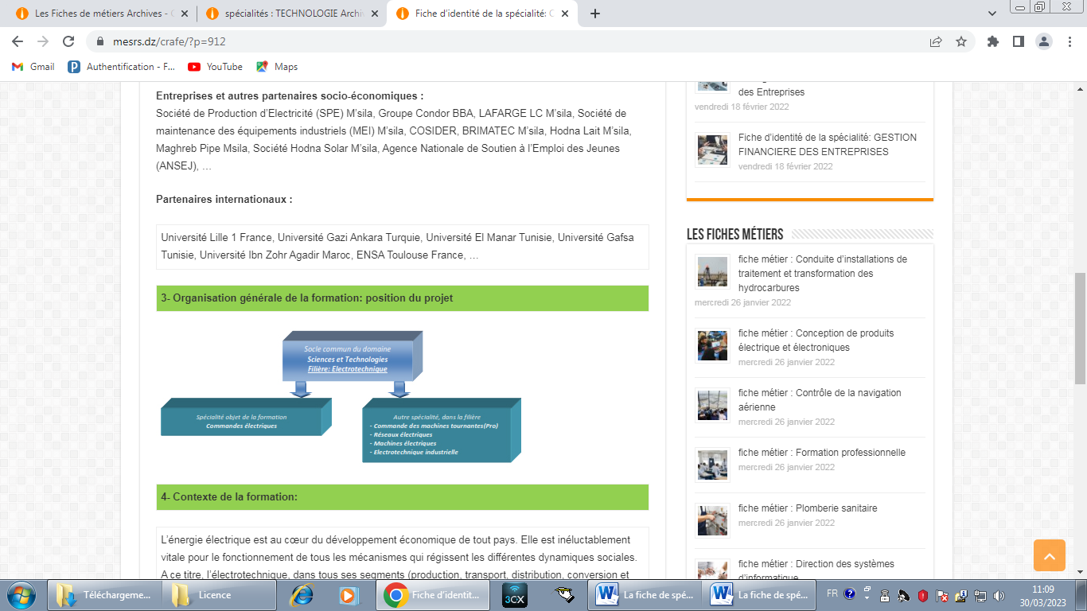

|  |
| --- |
| **4- Context of the training:** |

Electrical energy is central to the economic development of any country. It is inevitably vital for the functioning of all the mechanisms that govern the different social dynamics. As such, electrical engineering, in all its segments (production, transmission, distribution, conversion and control) has occupied a primordial place in the industrial sector of the countries and continues to be the subject of particular attention, scientific investment and continuous technological improvement.

|  |
| --- |
| **5- Objectives of the training:** |

Understand the physical phenomena linked to the transformations and use of electrical energy.

· Define and operate electrical power equipment and associated control systems, to produce energy or operate automation.

· Adapt to new technological specificities of companies.

|  |
| --- |
| **6- Profiles and skills targeted:** |

This training, by its academic nature, offers a balanced education in the four axes of the field of electrical engineering, namely: electrical machines, electrical networks, automatic control and power electronics. It is motivated by the fact that nowadays the four options of electrical engineering are very closely linked (an electric machine is often used with a static converter and the control circuit).

|  |
| --- |
| **7- Local, regional and national employability potential:** |

In general, the field of energy is still buoyant in terms of outlets in different fields: oil and gas industries, refrigeration, air conditioning, food processing, transport, chemical industries, hydraulics sector, heavy industries, etc.