|  |
| --- |
| **Identity card of the specialty**Academic License: Telecommunications |

**Level :**Academic license

**Domain :**Science and Technology

**Sector :**Telecommunications

**Speciality :**Telecommunications

|  |
| --- |
| **1- Location of the training:** |

**Faculty (or Institute)**:TECHNOLOGY

**Department**:Electrical Engineering.

References of the enabling order: Order no. 703 of 08/05/2015.

|  |
| --- |
| **2- External partners:** |

**Companies and other socio-economic partners**:/

**International partners**:/

**Other partner establishments**: Sonelgaz of the production SPE Bechar/Ghardaïa, Sonelgaz distribution Bechar, Sonelgaz of the Transport of electrical energy THT/HT GRTE Bechar /Oran, Algérie Telecom, NAFTAL (GPL, CPL) Bechar, GICA Saoura Bechar

|  |
| --- |
| **3- General organization of the training: position of the project** |

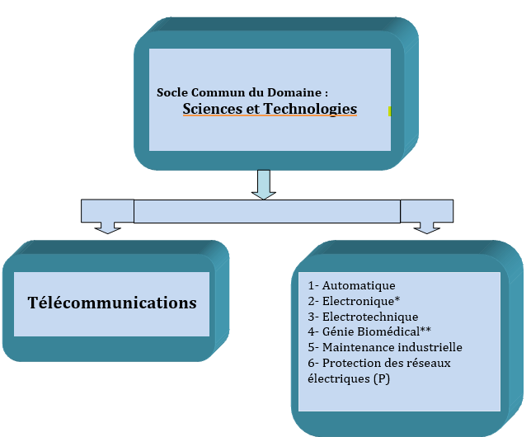

|  |
| --- |
| **4- Context of the training:** |

The need for telecommunications is becoming more and more vital for all the mechanisms that govern the different social dynamics. Indeed, ithe services which, until recently, were part of the professional context (collaborative work, Cloud Computing, etc.) are arriving in force in everyday life: social networks, online games, e-commerce, video on demand, mobile access to Internet services, etc.

On another register,the field of telecommunications, with the known technological progress and the modern methods employed, know no boundaries to its applications. The rapid evolution in the development of new telecommunication products requires users to better master the know-how to cope with this evolution.

It therefore becomes essential to invest this area through knowledge, scientific research and technological applications since their impacts on socio-economic balances are becoming more and more decisive...Mastering information is mastering the economy.

|  |
| --- |
| **5- Objectives of the training:** |

As a corollary, this justifies, in our view, the formation of the human framework which has always been the fundamental and essential component of all development processes. It is in this spirit that this training is offered.

The training provided in this license is of an academic nature. It is organized in the form of semester teaching units over 3 years of study. Througha hierarchical and coherent teaching, the student is led towards an acquisitionprogressive theoretical and practical knowledge in the field of technological sciences in general and telecommunications sciences in particular.

Thus, the program for the first year(semesters S1 and S2)is organized around a hard core of fundamental subjects (mathematics, physics and chemistry) supplemented by computer science.

The lessons of the third semester (common to the whole Electrical Engineering family) are reserved forthe acquisition of the basic subjects of electronics and electrical engineering. The fourth semesterEastcharacterized by the deepening of electronics subjects and the introduction of some telecommunications subjects.

The acquisition of the fundamental scientific bases necessary for an adequate specialization in the teaching of telecommunications (advanced electronics andlocal area networks, antennas and transmission media, signal processing techniques and advanced digital communications)are exclusively addressed during semesters 5 and 6.

In addition, this training also allows the student to develop his autonomy and his field of initiative, to evolve and adapt to changes in his profession through the End of Cycle Project and the Personal Project of the student.

|  |
| --- |
| **6- Profiles and skills targeted:** |

This training aims to raise the student to a level of knowledge and skills capable of enabling himcontinuewith easea Masters intelecommunications. On another side,the practical and professional knowledge acquired during his trainingwill be a springboard for himguarantor of immediate integration into the professional environment.

At the end of the training, young graduates should be able to:

* Know the fundamentals of telecommunications law;
* Understand Telecommunications systems and services;
* Engage effectively with users to understand their needs and issues;
* Participate in the development of specifications and contribute to the specifications of the topology of a network or a telecommunications installation;
* Install, configure, operate and administer a computer network;
* Manage network communication tools;
* Participate in the choice, implement andlead a network development and extension project based on an existing infrastructure;
* Master the standards and norms in terms of protocols, topologies, security and administration platforms;
* Dealing with both electronic and computer problems related to networks.

|  |
| --- |
| **7- Local, regional and national employability potential:** |

A country as vast as ours, where all the infrastructure of the telecommunications networks remains to be done or at least to be improved to bring it up to the level of the international standards in force in the developed countries, means that job opportunities for students coming out of this training are huge.

Young executives can apply formany functions ofin this vast sector of activity as assistants to telecommunications engineers, managers of the technical sales department, managers of the telecommunications infrastructure maintenance department, etc.

Graduates will work for equipment manufacturers, operators and companies that use or deploy mobile networks and services.

They can also create companies in collaboration with telecommunications engineers, innovating both in technological development and in the promotion of new uses.

The professional opportunities offered by this license are numerous and concern all sectors of activity:

Ministry of Post and Information and Communication Technologies(MPTIC):

Algeria Telecom, Mobilis, Ooredoo, Djezzy, Algerian Space Agency, Departments of Wilaya MPTIC, Third-party Telecommunications Operators.

***Ministry of Communication***:

Networks and Technical Structures of Broadcasting of Algeria (TDA).

***Ministry of National Defence***:

Transmission, Telecom Infrastructure

***Ministry of Interior***:

Transmission, Telecom Infrastructure.

***Ministry of Industry***:

Telecom infrastructure

***Ministry of Energy***:

Sonatrach (Transmission, Telecoms Infrastructure), Sonelgaz (Transmission, Telecoms Infrastructure), Third-party operators deploying a Telecommunications infrastructure.

***Ministry of Transportation***:

Airports (Transmission, Telecom Infrastructure, Air Traffic Control), Railways (Transmission, Telecom Infrastructure),Maritime navigation (Transmission),Weather center.