|  |
| --- |
| **Identity card of the specialty**Architecture |

**Level:**Licence

**Domain:**Architecture, Urban Planning and City Professions AUMV

**Sector:**Architecture

**Speciality:**Architecture

|  |
| --- |
| **1- Location of the training:** |

**Faculty (or Institute)**: faculty of technology, UTMB

**Department**:Architecture

References of the order authorizing the diploma to be prepared Order No. 835 of 27/07/2017

|  |
| --- |
| **2- External partners:** |

**Companies and other socio-economic partners**: Department of Architecture, Urban Planning and Construction DAUC of Béchar, Department of Housing DL Béchar, Department of Public Facilities of Béchar, Department of Transport of Béchar, Department of Hydraulics of Béchar, Department of Béchar, Land Registry Department of Béchar, Department of Public Works of Béchar, Land Agency of the commune of Béchar, Local authorities of the wilaya, The URBAT study office (Center for Studies and Achievements in Urbanism of Béchar), The Office of studies of the wilaya of Béchar, private BET, AADL Béchar.

**International partners**: name of international partners

**Other partner establishments**: Polytechnic School of Architecture and Urban Planning (EPAU), University Salah Boubnider Constantine 3, University of Science and Technology of Oran USTO.

|  |
| --- |
| **3- General organization of the training: position of the project** |

|  |
| --- |
| **4- Context of the training:** |

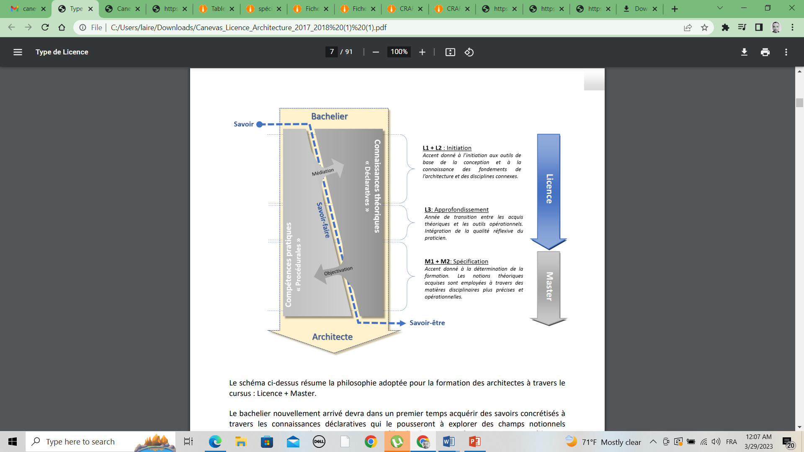

|  |
| --- |
| **5- Objectives of the training:** |

The academic license in Architecture is designed as a step towards a more complete training in the Architecture sector based on a base of training in architecture for obtaining the diploma of Academic or Professional Master, and allowing the student to acquire the necessary and sufficient knowledge to become an architect and practice the profession of architect according to the rules of the trade. The knowledge acquired will allow students to be autonomous and able to analyze and synthesize to choose the training profiles that will be offered to them according to their abilities, their background, their vocations but also the prospects offered by the labor market. employment to integrate them.

|  |
| --- |
| **6- Profiles and skills targeted:** |

The knowledge acquired at the end of this training which is spread over three years “academic license” constitutes only one stage in the process of training the “future architect”. They will allow him to benefit from a theoretical base made up of the fundamental knowledge necessary for access to the Master in Architecture which will constitute additional training specialized in various profiles offered within the framework of the Masters in Architecture. The resulting master's offers would allow the construction of more progressive professional careers capable of adapting to the needs and requirements of the market and the international, national and regional context. Also, the subjects taught in this planned "academic license" training are the basis of a specialized training in Architecture,

|  |
| --- |
| **7- Local, regional and national employability potential:** |

The planned training is not professionalizing but opens the way to other professionalizing training and in particular the masters in architecture: at the end of this training in two levels (license + master) and enriched by the personal work of the student as well as the confrontation of the real world of work through the internships planned in the two levels, the student will be a future executive motivated, progressive, responsible and ready for initiatives…. In the local and national market. With respect to the training itself, this offer of an academic license in architecture is an opportunity to enrich the content of the teaching programs already started within the framework of the reform and the reorganization of the teaching of architecture in the LMD system This teaching is designed in order to integrate and adapt it to regional and national training profiles in terms of housing, town planning of monuments and historic sites, etc. Thus, graduates applying for employment will have benefited from training adapted to the needs of the local and national market. The training at the end of this offer also aims at a certain goal, that of the qualitative improvement of the built environment in Algeria, of protection against the major risks of its compliance with local identity uses. town planning of historic monuments and sites, etc. Thus, graduates applying for employment will have benefited from training adapted to the needs of the local and national market. The training at the end of this offer also aims at a certain goal, that of the qualitative improvement of the built environment in Algeria, of protection against the major risks of its compliance with local identity uses. town planning of historic monuments and sites, etc. Thus, graduates applying for employment will have benefited from training adapted to the needs of the local and national market. The training at the end of this offer also aims at a certain goal, that of the qualitative improvement of the built environment in Algeria, of protection against the major risks of its compliance with local identity uses.