Identity card of the specialtyAcademic license: Electrotechnics
Level :Academic license
Domain :Science and Technology
Sector :Electrical engineering
Speciality :Electrical engineering
1- Location of the training:
Faculty (or Institute):TECHNOLOGY
Department:Electrical Engineering.
References of the enabling order: Order no. 703 of 08/05/2015.
2- External partners:
Companies and other socio-economic partners:/
International partners:/
Other partner establishments: Sonelgaz of the production SPE Bechar/Ghardaïa, Sonelgaz distribution Bechar, Sonelgaz of the Transport of electrical energy THT/HT GRTE Bechar /Oran, Algérie Telecom, NAFTAL (GPL, CPL) Bechar, GICA Saoura Bechar
3- General organization of the training: position of the project
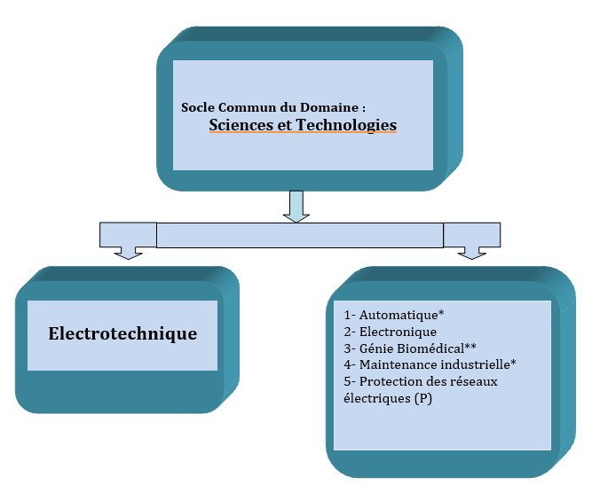
4- Context of the training:
This course is intended to be a common crucible without premature specialization and however leading to a progressive diversification towards any course, existing or future, of Master in electronics in the broadest sense.
This training, whichbelongs to the field of Science and Technology,is based on the one hand on fundamental subjects(maths, physics, chemistry and computer science up to 40%: 72/180 credits)and on the other hand on matters closely related to education.electronicsnamely: analog and digital electronics, servo control, power electronics, signal processing, etc. (87/180 credits eitheralmost 50%). On another register,the pedagogy in this training is resolutely oriented towards experience. To this end, a large part was intended for practical work sessions (25% of the total hourly volume): almost all of the specialty subjects are reinforced by practical work sessions. At the same time, students are trained in collective work in order to promote autonomy, a sense of responsibility and a spirit of initiative thanks to training including aProfessional Project and Business Management and aEnd of cycle project.
5- Objectives of the training:
The training is structured in 6 semesters, the first two of which (common base) concern all students in the fieldScience and Technology. The thirdsemester constitutes a pre-specialization and brings together all the students of the Electrical Engineering family. From semester 4, the lessons become specialized and are mainly oriented towards electrical engineering.
This license, by its naturegeneralist, offers a balanced education in the four axes of the field of electrical engineering, namely: electrical machines, electrical networks, automatic control and power electronics. It is motivated by the fact that nowadays the four options of electrical engineering are very closely linked (an electric machine is often used with a static converter and the control circuit).
6- Profiles and skills targeted:
The main objective of this training is to enable students to acquire a double qualifying diploma. So,the holders of this License will have acquired,at the end of this course,the skills necessary to integrate a professional environment inthe production, transport, distribution or exploitation of electrical energy. They can also, through the theoretical lessons acquired, continue their studies in one of the many existing Masters.
Thus, the Electrotechnical License gives the student good adaptability to enable him to assert himself in the face of new situations during his career. In this regard, it is able to:
- Understand the physical phenomena linked to the transformations and use of electrical energy.
- Define and operate electrical power equipment and associated control systems, to produce energy or operate automation.
- Know the different components of electrical networks and become familiar with the means of control and protection.
- Define the distribution, protection and control equipment, from high voltage to low voltage and their commissioning.
- Understand the real specificities of electrical networks and the means to be implemented for the stability of these networks.
- Adapt to new technological specificities of companies.
7- Local, regional and national employability potential:
All industries today run on electric power and use electric machines. It is therefore clear that theOpportunities in terms of employability for holders of this License throughout the national territory areguaranteed, on the one hand. Moreover,Andtaking into account national guidelines for the development of strategic sectors (seawater desalination, electricity production and renewable energies),private and/or public investors will certainly begin to exploit, in the near future, modern means of electricity production, which bodes well for a promising future for graduates of this sector.
In general, the field of energy is still buoyant in terms of outlets in different fields: oil and gas industries, refrigeration, air conditioning, food processing, transport, chemical industries, hydraulics sector, heavy industries, etc.

