|  |
| --- |
| **Identity card of the specialty**Academic License: Electronics |

**Level :**Academic license

**Domain :**Science and Technology

**Sector :**Electronic

**Speciality :**Electronic

|  |
| --- |
| **1- Location of the training:** |

**Faculty (or Institute)**:TECHNOLOGY

**Department**:Electrical Engineering.

References of the enabling order: Order no. 703 of 08/05/2015.

|  |
| --- |
| **2- External partners:** |

**Companies and other socio-economic partners**:/

**International partners**:/

**Other partner establishments**: Sonelgaz of the production SPE Bechar/Ghardaïa, Sonelgaz distribution Bechar, Sonelgaz of the Transport of electrical energy THT/HT GRTE Bechar /Oran, Algérie Telecom, NAFTAL (GPL, CPL) Bechar, GICA Saoura Bechar

|  |
| --- |
| **3- General organization of the training: position of the project** |

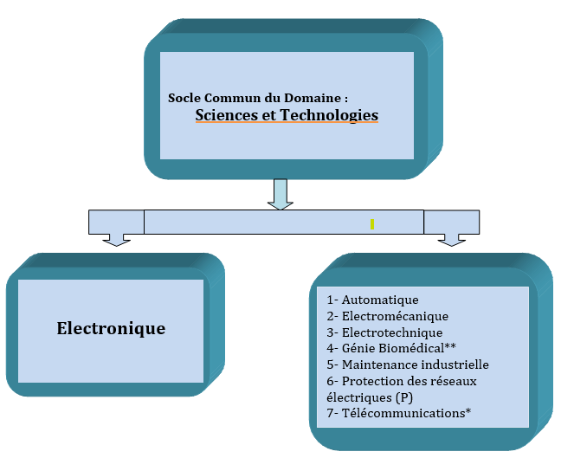

|  |
| --- |
| **4- Context of the training:** |

Electronics are present in all areas. The quasi-systematic digitization of information challenges traditional areas such as telephony and automation. The success of the Internet, mobile phones and communication networks is growing and requires major infrastructures which will only grow in the future.Technological breakthroughs in the manufacture of cells produced with standard silicon wafers are constantly being improved. The level of efficiency of these cells should ultimately make it possible to offer a real alternative to fossil fuels.

Moreover, highly technological sectors such as aeronautics, automotive, robotics, modern medicine, space are excessive consumers of electronic products.

It therefore becomes essential to invest major resources in this sector in order to develop the field of electronics through scientific research, equipment and training. Investing in the human component is, in our view, by far the most fundamental and the guarantee of any development process of a society.It is for this reason that this training is offered.

|  |
| --- |
| **5- Objectives of the training:** |

This course is intended to be a common crucible without premature specialization and however leading to a progressive diversification towards any course, existing or future, of Master in electronics in the broadest sense.

This training, whichbelongs to the field of Science and Technology,is based on the one hand on fundamental subjects(maths, physics, chemistry and computer science up to 40%: 72/180 credits)and on the other hand on matters closely related to education.electronicsnamely: analog and digital electronics, servo control, power electronics, signal processing, etc. (87/180 credits eitheralmost 50%). On another register,the pedagogy in this training is resolutely oriented towards experience. To this end, a large part was intended for practical work sessions (25% of the total hourly volume): almost all of the specialty subjects are reinforced by practical work sessions. At the same time, students are trained in collective work in order to promote autonomy, a sense of responsibility and a spirit of initiative thanks to training including aProfessional Project and Business Management and aEnd of cycle project.

|  |
| --- |
| **6- Profiles and skills targeted:** |

This Degree in Electronics is for academic purposes. It primarily aims to:

* Train students capable of pursuing studies in all types of existing Masters in electronics, or even later in doctorate,
* Acquire a diploma recognized by the socio-economic environment (regional and national) and adapt to the current and future needs of our society.

Indeed, this training is a springboard for a very wide range of electronics professions (space exploration, automotive, radio, television, telephony, medicine, robotics, imaging, industrial computing, embedded systems, etc.). Training in this field therefore offers many professional opportunities in a wide variety of industries.

|  |
| --- |
| **7- Local, regional and national employability potential:** |

At the end of this training, the graduate can not only pursue higher education (Master, Doctorate) but he is also able to occupy a job as a general-purpose manager in electronics, called upon to meet both national and regional needs:

(At the national level)

* Electricity production and distribution company;
* Telecommunications sector (telephone operators);
* SMEs in the electronics sector, …

(At the regional level)

* Industrial steel companies;
* Chemical Engineering Companies;
* SMEs in microcomputing and agri-food.