|  |
| --- |
|  |
|  |
| **Identity card of the specialty**: 3rd year License: Microbial Biotechnology. |

**Level:**Licence

**Domain:**Biology

**Sector:**Biotechnology

**Speciality:**Microbial Biotechnology

|  |
| --- |
| **1- Location of the training:** |

**Training location:**

**Faculty (or Institute):**science of nature and life

**Department :**Biology

**References of the authorization decree of the license:**Order N: 1600 of October 06, 2016.

|  |
| --- |
| **2- External partners:** |

**- Other partner establishments:**

**-**Abu Bakr Belkaid University of Tlemcen

- Mustapha STAMBOULI University of Mascara

**- Companies and other socio-economic partners:**

- Béchar Hospital (240 beds)

- ERIAD (Bechar)

- Algerian Center for Quality Control and Packaging (CACQE).

- Economic sector of the region.

- SUDLAIT Bechar

**International partners:**

Institution: TAHRI Mohamed-Béchar University - License title: Microbial biotechnology. Academic year: 2018 - 2019page 6

|  |
| --- |
| **3- General organization of the training: position of the project** |

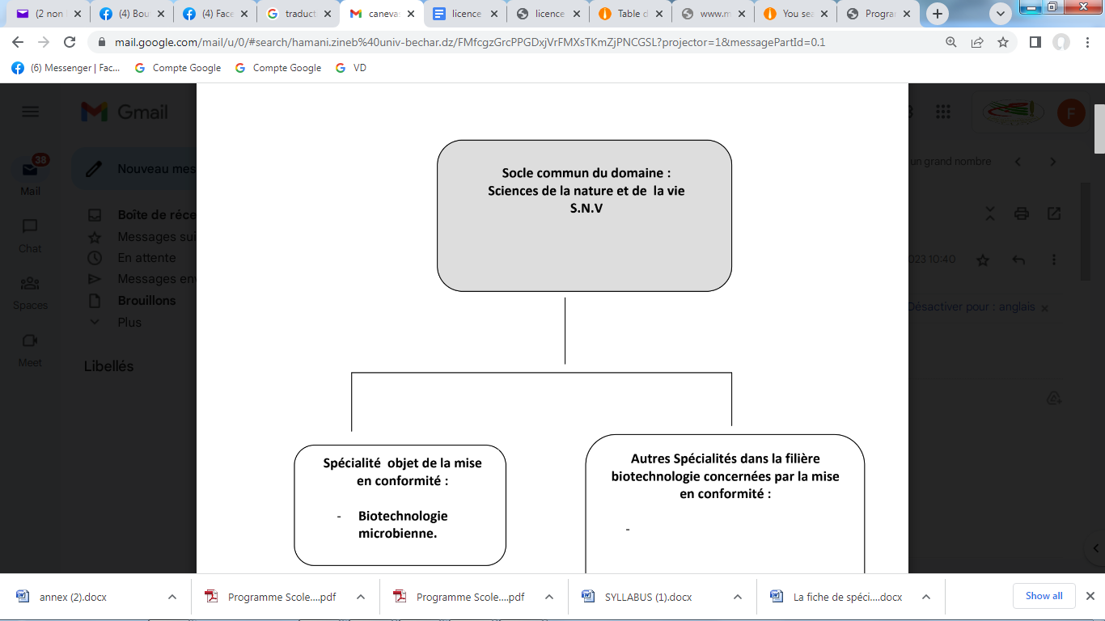

|  |
| --- |
| **4- Context of the training:** |

1. Professional innovation.

2. Evaluation by students.

3. The quality and performance of training.

4. External evaluation by other universities.

|  |
| --- |
| **5- Objectives of the training:** |

Most ecosystems and natural environments, especially food or manufactured products are contaminated with fungi. There are currently more than 120,000 species, sometimes useful, often harmful. More than 5000 plants are attacked by fungi.

The ecology of fungi and their distribution depend on their nutrition. As a result, these organisms can be:

1- saprophytes (recycling of natural polymers by the secretion of extracellular enzymes)

2- Symbiotic either with plant roots (mycorrhiza) or with algae and cyanobacteria (lichens).

3- Pathogenic (production of toxins, ergot alkaloids).

They are also of remarkable industrial importance:

To. biomass production

b. production of enzymes, organic acids, and antibiotics.

Of more than 2000 known enzymes, 40% are of fungal origin

Indeed, it is currently concluded that these microorganisms secrete in all environments, many metabolites qualified as secondary non-essential to growth and that we do not know their physiological roles but more often present a danger to human and animal health (mycotoxins), and they are rigorously monitored by the WHO.

The proposal for a license in this field aims to invite the student to acquire a theoretical understanding supported by practical knowledge.

As a result, we think we are training managers who can enhance the usefulness of these fungi, but also protect the community from their danger.

|  |
| --- |
| **6- Profiles and skills targeted:** |

The training leading to the Academic License is designed and organized within the framework of close partnerships with the professional world. It leads to the acquisition of new knowledge and skills in the sectors concerned and leads to complementary or cross-disciplinary disciplines.

It aims to:

- Provide the foundations of a professional activity and lead to autonomy in the implementation of this activity.

- Enable, as part of continuing education, people involved in the life of research to validate the knowledge and skills acquired in their future activities, to complete them and to obtain the recognition of a national diploma.

Give its holders the means to cope with future changes in employment, control the development of their professional career and their qualification needs and allow them to continue their training course within the framework of education throughout their the life.

|  |
| --- |
| **7- Local, regional and national employability potential:** |

The development of the agro-food industry, the pharmaceutical industries, the proliferation of medical, pharmaceutical and quality control laboratories (for the latter at the level of municipalities, wilayas, customs services) suggest the need for "manpower". scientific work. Having acquired a multidisciplinary training at Bac +5, graduates can occupy many positions in different sectors of activity.

The outlets are very varied. They are located mainly in the fields of microbiology at the "engineer" level or at the "researcher" level after a thesis, in secondary and higher education.

E – Gateways to other specialties:

To be admitted to the various training courses leading to the professional license, students must provide proof of national knowledge attesting to two years of higher education in the common core of the field of natural and life sciences validated grouped into semesters (S1, S2 , S3 and S4).

The gateways offered for the possible continuation of studies are organized as follows:

The overall number of credits required by the administration is essential. Thus, the apparent partial credit of a compulsory module should be obtained by a single final written test. On the other hand, the apparent partial credit of an optional module should be obtained by a single final test followed by a personal project drawn up by the student and presented to a jury.