|  |
| --- |
| **Identity card of the specialty: Automation and Industrial Computing** |

**Level :**Academic Masters

**Domain :**Science and Technology

**Sector :**Automatique

**Speciality :**Automatic and informatic industrial

|  |
| --- |
| **1- Location of the training:** |

|  |
| --- |
| **Faculty/Institute: TECHNOLOGY.**  **Department: Electrical Engineering.**  **References of the authorization order:**Order no. 1201 of 08/09/2016. |

|  |
| --- |
| **2- External partners:** |

**Other partner institutions:/**

**Companies and other socio-economic partners:**

|  |
| --- |
| **Other partner establishments**: Sonelgaz of the production SPE Bechar/Ghardaïa, Sonelgaz distribution Bechar, Sonelgaz of the Transport of electrical energy THT/HT GRTE Bechar /Oran, Algérie Telecom, NAFTAL (GPL, CPL) Bechar, GICA Saoura Bechar |

**International partners: /**

|  |
| --- |
| **3- General organization of the training: position of the project** |

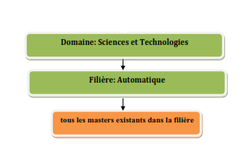

|  |
| --- |
| **4- Context of the training:** |

|  |
| --- |
| The doctoral project is integrated into the national scientific policy and the skills of the doctoral training team which proposes it and which will host it. The description of the research project is structured around the state of the art in the field and the previous work of the scientific community and the team on the subject. |

|  |
| --- |
| **5- Objectives of the training:** |

|  |
| --- |
| The doctoral program will give doctoral students all the skills necessary for research at doctoral level and will enable them to progress in their career as a business executive, researcher or teacher-researcher. The objective of the doctorate is to be able to make an original contribution to knowledge, interpretation or scientific development in this field of knowledge. |

|  |
| --- |
| **6- Profiles and skills targeted:** |

|  |
| --- |
| The program will support the research project for both academic and operational purposes. During the doctoral research, the doctoral student will develop his capacities for autonomy, analysis, structuring, hierarchization, prioritization, and planning. At the end of the doctoral project, the doctor will have a high level academic and scientific culture. They will be able to justify their work and defend it orally before a jury made up of experts in the discipline. |

|  |
| --- |
| **7- Local, regional and national employability potential:** |

– Teacher-researcher,

– High-level executive in a company,

- Etc. …