|  |
| --- |
|  |
|  |
| **Identity card of the specialty**(Academic License) |

**Level :**Academic License

**Domain :**Natural and Life Sciences (SNV)

**Sector :**Sciencefood

**Speciality :**Food, Nutrition and Pathologies

|  |
| --- |
| **1- Location of the training:** |

**Faculty (or Institute)**: Natural and life sciences (SNV)

**Department**: Biology

**References of the enabling orderof the license: Order No. 1600 of October 6, 2016**

|  |
| --- |
| **2- External partners:** |

**Companies and other socio-economic partners**: Tourabi boudjemaa hospital in Béchar, ERIAD Béchar, Algerian Center for Quality Control and Packaging (CACQUE), Economic sector of the Béchar region.

**International partners**:/

**Other partner establishments**: Abou Bekr Belkaid Tlemcen University, Mustapha Stambouli University Mascara

|  |
| --- |
| **3- General organization of the training: position of the project** |

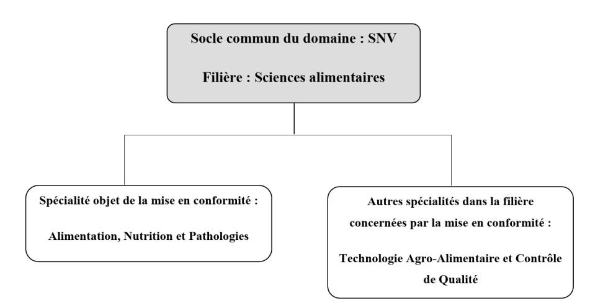

|  |
| --- |
| **4- Context of the training:** |

The relationships between food, nutrition, health and well-being are now the subject of real socio-economic issues in the medium and long term in industrialized countries. Given the demand from society and the food industry, it has therefore become essential for our country to develop and structure research in the field of human nutrition.

This license aims to acquire not only scientific and solid skills in human nutrition, but also economic ones where the candidate develops good capacities for analysis and adaptation.

It integrates the most recent knowledge in the study of metabolisms, eating behaviors and the prevention of pathologies directly or indirectly influenced by nutrition (obesity, metabolic syndrome, cardiovascular diseases, diabetes, certain cancers, etc.). It aims to:

-Study the mechanisms responsible for the harmful or toxic effect of nutrients or xenobiotics and the possibilities, in the nutritional field, of protecting the organism against these toxic effects.

– train specialized personnel capable of working mainly in the laboratories of companies in the agri-food sector or laboratories specializing in microbiological analyses. In addition, graduates of this program will also have developed skills that will enable them to perform microbiological analyzes in the medical field. They will thus be able to work in companies or establishments linked to this sector of activity.

The route responds particularly well to societal demand (consumer demand for the healthiest possible diet without negative effects on health).

|  |
| --- |
| **5- Objectives of the training:** |

This teaching constitutes a basic training of the future graduate in the field of Food, Nutrition and Pathologies. Nutrition is the science of how foods, nutrients, and other dietary components affect growth and development in health and disease. Nutritional science also examines theenvironmental, socio-cultural, psychological and behavioral aspects of food and diet. Consumer concerns about food and water safety, food quality and regulations are important issues addressed in nutrition. Furthermore, this program provides students with the theoretical and practical knowledge to engage in food safety, the development of innovative products, diets and lifestyles for health, as well as research on functional ingredients for health. -be.

This training is designed with an academic objective and professional integration that promotes the adaptation of students to the realities of food science laboratories, business and technological development. The lessons given to students whose language of communication is French, will be reinforced by practical work and outings in the food industry (IAA), analysis laboratories (LA), thus contributing to the formation of the scientific spirit. , communication and the development of the student's intellectual abilities.

The Academic License offers the student:

- A deepening of knowledge and a broadening of skills in the sectors concerned (IAA and LA);

- A capacity for research in Human Nutrition and/or innovation in the development and creation of products with nutritional or health value;

- An apprenticeship in the implementation of their knowledge and skills in the targeted professions (management of metrology, quality, control and testing);

- A power to identify food needs and their coverage by the ration in healthy humans by integrating particular physiological situations;

- General training aimed, in particular, at facilitating the mastery and use of written and oral expression, of at least one modern foreign language (English), of computer tools applied to data processing, as well as the improvement of knowledge of the business.

|  |
| --- |
| **6- Profiles and skills targeted:** |

The training leading to the Academic License is designed and organized within the framework of close partnerships with the professional world.

It leads to the acquisition of new knowledge and skills in the sectors concerned and leads to complementary or cross-disciplinary disciplines.

It aims to:

- Provide the foundations of a professional activity and lead to autonomy in the implementation of this activity;

- Enable, as part of continuing education, people engaged in research to validate the knowledge and skills acquired in their future activities, to complete them and to obtain the recognition of a national diploma;

- Give its holders the means to cope with future changes in employment, control the development of their professional career and their qualification needs and allow them to continue their training course within the framework of lifelong education. of life.

|  |
| --- |
| **7- Local, regional and national employability potential:** |

The main opportunities for this Academic License in food control and analysis laboratories, medical analysis laboratories, human health services, companies manufacturing, packaging, preserving agri-food products, equipment and treatment of agro-food waste.